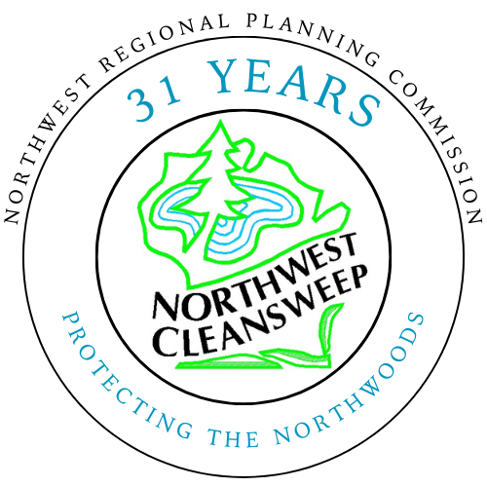
2026 NW Wisconsin Household Hazardous Waste Collection Schedule

WHO CAN ATTEND

Residential households from each participating county can utilize any of the Cleansweep collection events. Proof of residence may be required.

Businesses qualified as Very Small Quantity Generators (VSQG) and Agricultural Producers (farmers/farms) wanting to dispose of chemicals MUST preregister at least two weeks in advance of the event and provide a full list of materials and prepay or provide authorization. Contact Colin Barrington, Veolia Environmental Services at colin.barrington@veolia.com.

Farmers/Farms may dispose of up to 200 pounds of pesticides only for free at the collection events, with preregistration and proof of business required.
DATE | COUNTY | LOCATION | TIME | CONTACT
Wednesday, June 10th | Taylor | Medford – Taylor County Fairgrounds, State Hwy 13 & WI-64 (No Rx/No Sharps)* | 10:00 am – 2:00 pm | Kyle Noonan  Taylor County Zoning Department | (715) 748-1485
Thursday, June 11th | Ashland | Ashland – ABC Raceway, 2187 Butterworth Rd. (Accepts Rx and Sharps) | 2:00 pm – 6:00 pm | Lissa Radke  Ashland County UW Extension | (715) 682-7071
Friday, June 12th | Rusk | Tony – N5391 Little X Road  (Accepts Rx and Sharps) | 12:00 pm – 4:00 pm | Charmaine Riddle  Rusk County Recycling | (715) 532-2167
Thursday, July 23rd | Bayfield | Iron River – Fairgrounds, 7080 N. Main Street  (Accepts Rx and Sharps) | 2:00 pm – 6:00 pm | Theresa LaChapelle  Bayfield County UW Extension | (715) 373-3285
Wednesday, August 5th | Douglas | Solon Springs – Solon Springs Garbage & Recycling Center, 11523 Business 53 (No Rx/No Sharps)* | 2:00 pm – 6:00 pm | Abigail Gilberg  NWRPC | (715) 635-2197
Thursday, August 6th | Burnett | Siren - Burnett Co. Hwy Dept 8150 St. Rd. 70 (Accepts Rx Only) | 10:00 am – 2:00 pm | Abigail Gilberg  NWRPC | (715) 635-2197
Friday August 7th | Washburn | Minong – Minong Transfer Station, W5775 Transfer Station Dr. (No Rx/No Sharps)* | 10:00 am – 2:00 pm | Abigail Gilberg  NWRPC | (715) 635-2197
Tuesday, September 22nd | Price | Park Falls- St. Croix Rod 1333 4th Ave S (No Rx/No Sharps)* | 2:00 pm – 6:00 pm | Evan Lund  Price County Land Conservation & Zoning | (715) 339-2550
Wednesday, September 23rd | Sawyer | Hayward – Sawyer County Fairgrounds 14655 Co. Hwy B  (Accepts Rx and Sharps) | 2:00 pm – 6:00 pm | Ariga Grigoryan  Sawyer County UW Extension | (715) 638-3295
CLEANSWEEP WILL ACCEPT

Household hazardous waste will be accepted at the above locations and only at designated times. Items will be taken for free from residential household properties, except for FEE ITEMS noted below. Acceptable items include materials such as, oil-based paints, aerosol spray paints and lubricants, solvents, pesticides, fertilizers, household and hazardous cleaners, corrosives, flammables, mercury, lead tackle and shot, old gas, antifreeze, and other chemicals you wouldn’t consider dumping. Mercury containing thermostats, switches, and thermometers, and lead based paint will also be accepted.
CLEANSWEEP WILL NOT ACCEPT

- Latex Paint
- Empty Paint Cans
- Oil Filters
- Motor Oil
- Explosives, Flares or Fireworks
- Freon 11 & 12
- Radioactive Materials (including smoke/Co2 alarms)
- Ammunition
- Compressed Gas Cylinders-any size
- Recyclables
- Appliances
- Asbestos
- Biological or Infectious Wastes
- Sharps or EpiPens (unless noted above)
- Spray Foam Cylinders
- PFAS Containing Items
UNWANTED Rx MEDICATION DISPOSAL

Residents having expired and unwanted medications or sharps may bring items to the event locations listed above. Please leave pills in packages and containers with labels attached to assist in identification of medications. Sharps will be accepted unless noted in county details above.
FEE ITEMS

The items below will be accepted at the collection events for a fee.

- $2.00 per fluorescent bulb (tube, CFL, circular)
- $2.00 per standard Incandescent light bulb
- $4.00 per shatter shield tube
- $6.00 per tanning bed or UV bulb
- $3.00 per HID or LED bulb
- $3.00 lb. PCB Ballast
- $2.00 lb. Non-PCB Ballast
- Lithium Ion & LI Primary Batteries $10.00 lb.
- All other batteries $2.00 lb.
Northwest Cleansweep is a cooperative venture supported by: Ashland, Bayfield, Burnett, Douglas, Price, Rusk, Sawyer, Taylor and Washburn Counties; Wisconsin Department of Agriculture, Trade and Consumer Protection, and Northwest Regional Planning Commission.

Northwest Cleansweep will accept the first 200 lbs. of chemicals from farmers or abandoned farms for free. Farmers with agricultural related wastes can participate at any of the household hazardous waste collection events or at the permanent collection site in Spooner.
Pre-registration is required
Call 715/635-2197
AGRICULTURAL PROGRAM
Materials will be accepted from businesses for a reasonable fee. Please call 715/635-2197 ahead of time to make arrangements.

BUSINESS COLLECTION PROGRAM

UNACCEPTABLE ITEMS

